HZ-F01 4G HD Body Camera

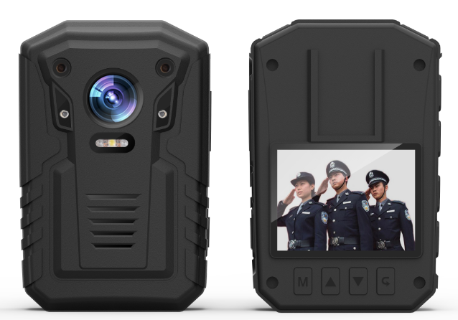
Product Brief：
HZ-F01 4G Body Camera is the latest introduction of our company，The product adopts high-speed processor and embedded real-time operating system, and integrates high-definition video, audio, 4G wireless communication module, GPS, storage, wifi module，It can be widely used in law enforcement departments such as the public, inspection, law, armed police, industry and commerce, taxation and so on. Law-executor use real-time recording of the scene, the device collected evidence in the field of law enforcement, standardize law enforcement activities, and can be used for real-time video and audio information transmission, voice intercom, PTT cluster intercom functions through the 3G/4G wireless network monitoring system; Powerful CMS platform can be used for real-time command and scheduling of equipment.

Product features：
- Built in Ambarella A12 chip，Stable operation of the product，With high definition, low illumination industrial grade 1/3 CMOS photosensitive element, the image effect is outstanding, the color is gorgeous and true.
- Using embedded real-time operating system and Linux dual system, faster boot , more stable system operation, more powerful functions, can effectively prevent viruses and other intrusion systems。
- professional waterproof and dustproof design, IP66 waterproof level can effectively prevent rain and dust into.
- Industrial grade plastic and bare metal structure design, can withstand 2 meters free falling body, and the data will not be damaged.
- Full HD 1080P 30fps camera, H.264 encoding, using Ambarella Smart ultra low bit stream design, reduce storage capacity.
- Take pictures, 16 million pixels, JEPG format。
- HD 2 inch screen, the diagonal is larger than 52mm, can choose to turn off the screen.
- Built-in 4G module, support 4G wireless transmission, can be connected to the platform for centralized monitoring。
- Built-in WIFI module, support WIFI wireless transmission (optional).
- Built in GPS or Beidou (optional) positioning module, support position real-time tracking and track playback。
- Support two-way voice calls, support PTT intercom。
- Fast power on, power up to full function video <3 seconds。
- Emergency alarm function, support long press alarm button, send alarm information function to the platform。
- 170 degree wide-angle lens.
- Double microphone design, high sensitivity, high signal-to-noise ratio recording function。
- "laser positioning" design, to ensure that the video picture is not offset, the evidence is clear and effective law enforcement.
- Bottom multifunctional interface (external charging pedestal and camera,), Mini USB interface for charging and transmitting data。
- One button operation, video / recording / photo and so on, support one click operation, and can quickly view the video data。
- With full automatic or manual infrared night vision function, built-in two high-power infrared light source, after opening the night vision function, you can see the distance from the prototype 8m characters facial features, and can see the body contour from the prototype 15m。
- A key video function, in shutdown state, for law enforcement emergencies, Press record button into the video state, to ensure that no omission of any law enforcement data。
- Large capacity battery design, supports continuous video recording for 8 hours (4G working time is 4.5 hours)。
- Low power design, video recording power <1.5W。
- Support Bluetooth headset, wear more flexible and comfortable (optional support)。
- External camera: can be connected to digital 1080P high-definition lens (optional support).
- Charging seat: the device is equipped with special charging seat, which can be used to charge and transmit data。

Application industry：
Traffic police, patrol police, urban management, coastal defense, armed police, insurance, fire fighting, electric power, medical treatment, emergency rescue and other fields.

Product specification：
system | RTOS + Linux dual system
Video and audio input | Video compression standard | H.264
Video and audio input | Video file format | MP4
Video and audio input | Audio compression standard | G711/ADPCM/AAC
Video and audio input | Audio input | Double microphone
Codec | Video resolution | 1080P/720P/VGA
Codec | Frame rate | 1080p@30fps/720p@30fps
Codec | Bit rate | high/middle/low
Positioning function | Built-in GPS or BD
Storage | Type | microSD(TF card)
Storage | capacity | 32GB/64GB/128G
Wireless | 3G/4G | TD-SCDMA / EVDO / WCDMA / LTE-TDD FDD
Wireless | WiFi (optional） | 802.11b/g, 2.4GHz
Wireless | WiFi encrypt | WPA2
Wireless | Interface | Mini USB/30 Pin
Other | LED | High brightness LED
Other | white balance | support
Other | Auxiliary light source | Infrared light, laser positioning, highlight LED flash
Other | Log function | support
Other | working temperature | -20℃～+60℃
Other | Storage temperature | -40℃～+70℃
Other | Working humidity | 40％--90％
Other | Battery | 4000 mAh
Other | working time | recording 8 hours (Networking 4.5 hours)
Other | Protection grade | IP66
Other | drop | 2meters
Other | weight | 160g
Other | Charger | support，charge and Transmission data
Other | Size | 96*62*34mm

