
^{15th} January, 2018
MORE THAN JUST RECORDING MDVR
Shenzhen, China

Dual Dash Cams, Data logging, WIFI and 4G, All in One Smart Little Package
The T-Box is an all-in-one telemetry system comprising of a cameras, a tracker and a DVR that can be installed into any vehicle in only 5 minutes. Compare this to the 1-2 hour installation time of similar products, and you can see how Coointech’s solution can quickly save a large amount of time and money!

The All-in-One system is designed for use in company cars, taxis, buses, law enforcement and delivery vehicles. The forward-facing camera records the road in front keeping false insurance claims at bay, whereas a guardian camera keeps an eye on the interior and the driver.

If 2 cameras is not enough then 3 more can be added to the system to provide all round coverage of a vehicle. A whole host of other sensors such as microphones, door contacts, indicator signals and ignition switches can be monitored and used to trigger alarms in the accompanying Central Management Software.

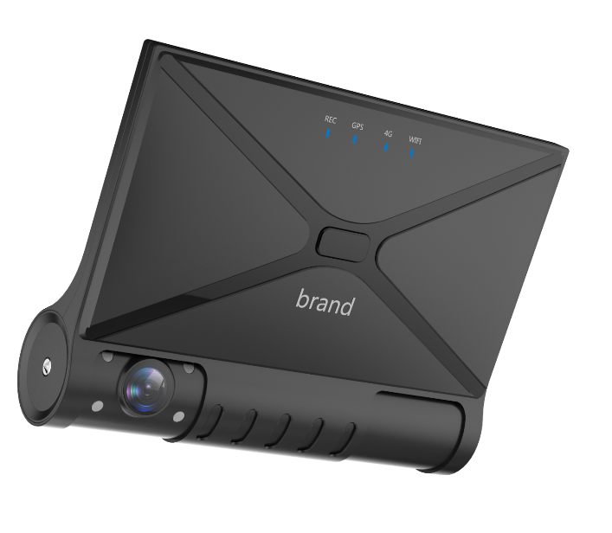
Live video, event snapshots, vehicle routes, speed, travel time, excessive braking and more can be saved onto a local hard drive and then uploaded onto a remote server, giving you ample data to produce highly detailed reports of your entire fleet.

Manage all this from anywhere in the world using our dedicated software.

To learn more about Coointech and see how our latest products can help manage your fleet, please visit our website www.coointech.com
Get in touch with our sales team at sofia.mdvr@gmail.com

